FDA Remove the Risk Campaign
Drop-in Email Marketing Content

Remove the Risk of Unused Opioids
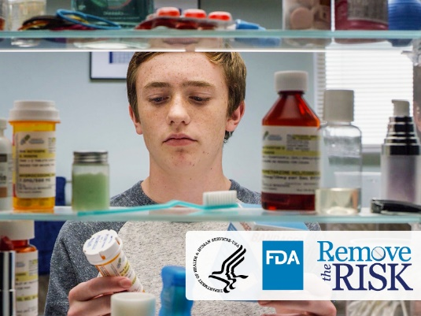
The United States is experiencing a devastating opioid crisis. More than 100 Americans die every day from overdoses involving opioids, and millions are addicted to opioids. You can help keep your family and community safe by getting rid of unused prescription opioids in your cabinets, drawers, or anywhere else you store medicine. Reduce the chance that others accidentally or intentionally may take these dangerous medicines.

Figure 1 Teenage boy examines medicines inside a medicine cabinet.

Why Safe Opioid Disposal Is Important

What are opioids?
Prescription opioids are powerful, pain-reducing medicines. You can find them in pill forms, syrups, or prescription patches. Commonly prescribed opioids include hydrocodone, morphine, and oxycodone.

Why are unused opioids dangerous?
Your medicines could get into the wrong hands. Half of people who misuse prescription opioids get them from a friend or family member, according to data from the National Survey on Drug Use and Health. Accidental exposure to medicines in the home is a major source of poisoning emergencies among children.

Where can I find more information on safe opioid disposal?
The U.S. Food and Drug Administration (FDA) launched the Remove the Risk campaign, which aims to raise awareness about the serious dangers of keeping unused prescription opioids and to provide information about safe disposal of these medicines.

Find Remove the Risk educational resources, including videos, fact sheets, and information, to help determine your best disposal option at www.FDA.gov/DrugDisposal and www.FDA.gov/DeshacerseDeMedicamentos (Spanish).

Use #RemoveOpioidRisk to follow updates from the campaign and to join the conversation on social media.

