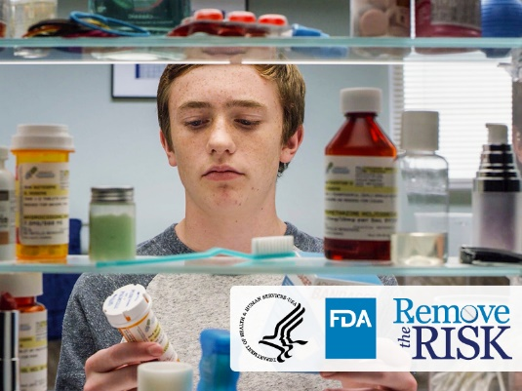

* Logo for the Food and Drug Administration’s “Remove the Risk” campaign
* Logo for the U.S. Department of Health and Human Services
* Logo for the Food and Drug Administration
* Teenage boy picks up pill bottle and box of bandages and studies them closely.

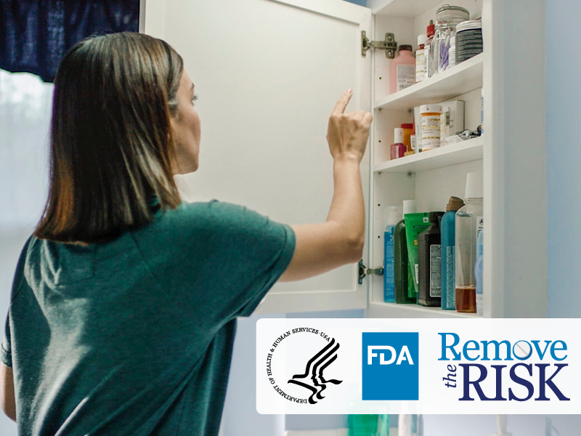

* Logo for the Food and Drug Administration’s “Remove the Risk” campaign
* Logo for the U.S. Department of Health and Human Services
* Logo for the Food and Drug Administration
* Woman scans items in medicine cabinet to locate opioid pain medicines.

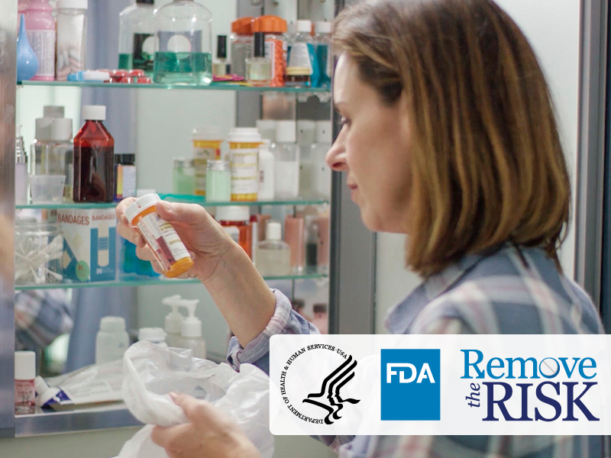

* Logo for the Food and Drug Administration’s “Remove the Risk” campaign
* Logo for the U.S. Department of Health and Human Services
* Logo for the Food and Drug Administration
* Woman examines bottle of opioid pain medicine from her medicine cabinet.